1. Sign up for a free Jira account (cloud version), create a new project using the Scrum template, and take a screenshot of your empty Scrum board.
Ans:
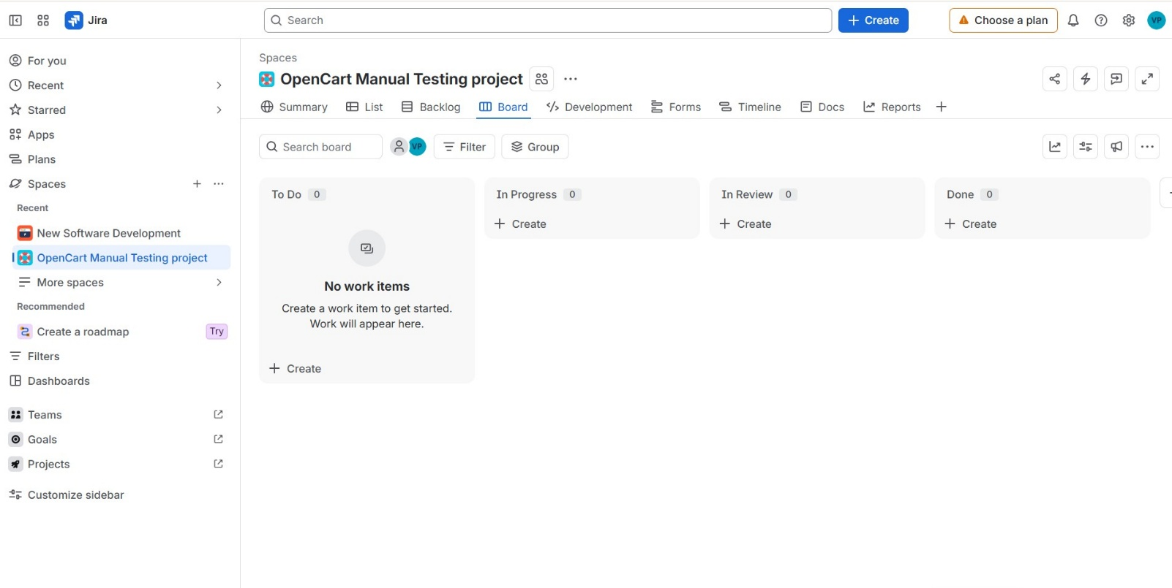

2. In your Jira Scrum board, create an epic named 'Food Delivery App Features' and add three user stories under it: 'As a user, I want to search for restaurants', 'As a user, I want to track my order in real-time', and 'As a user, I want to pay using UPI'.
Ans:
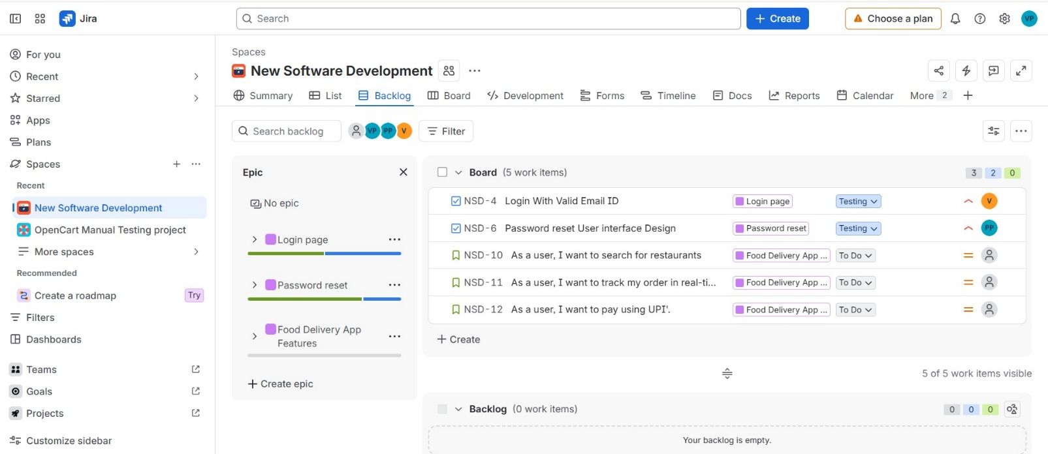

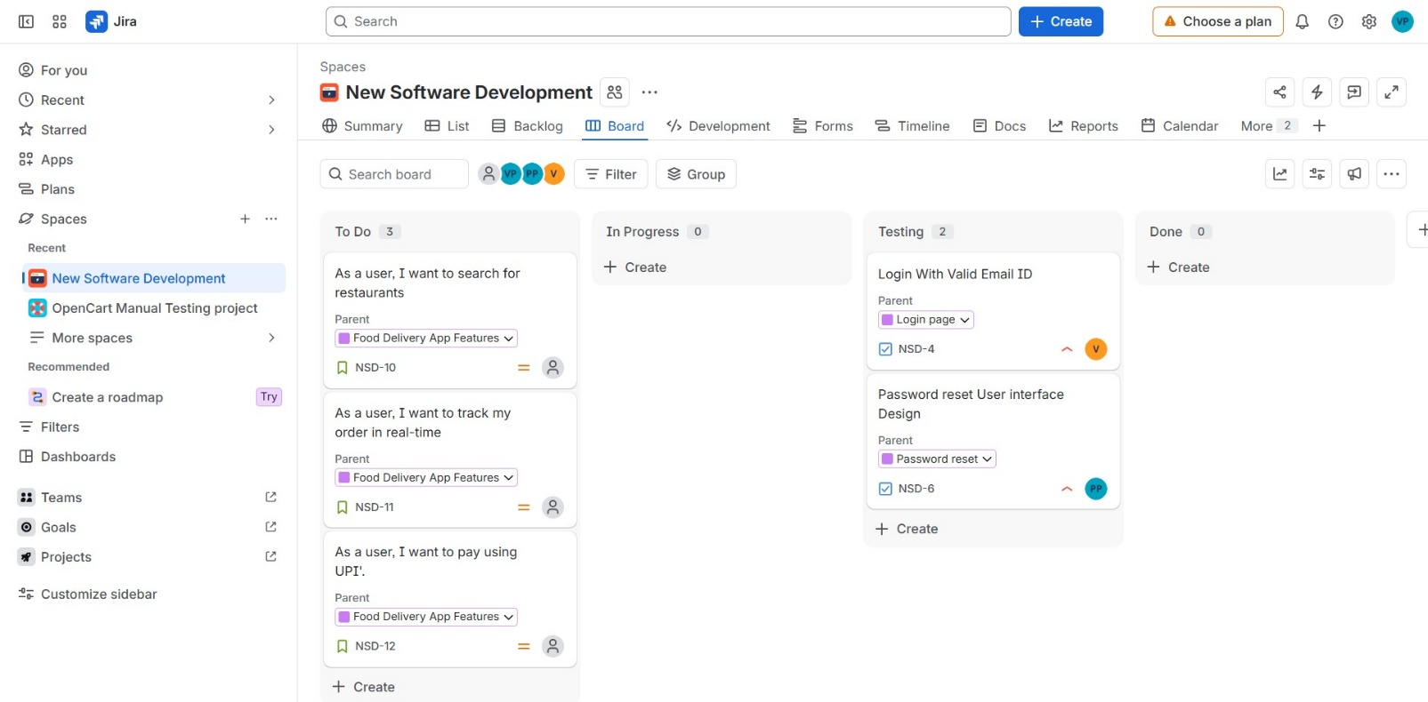

3. For the user story 'As a user, I want to search for restaurants', add two sub-tasks: 'Design search UI' and 'Integrate restaurant API'.
Ans:
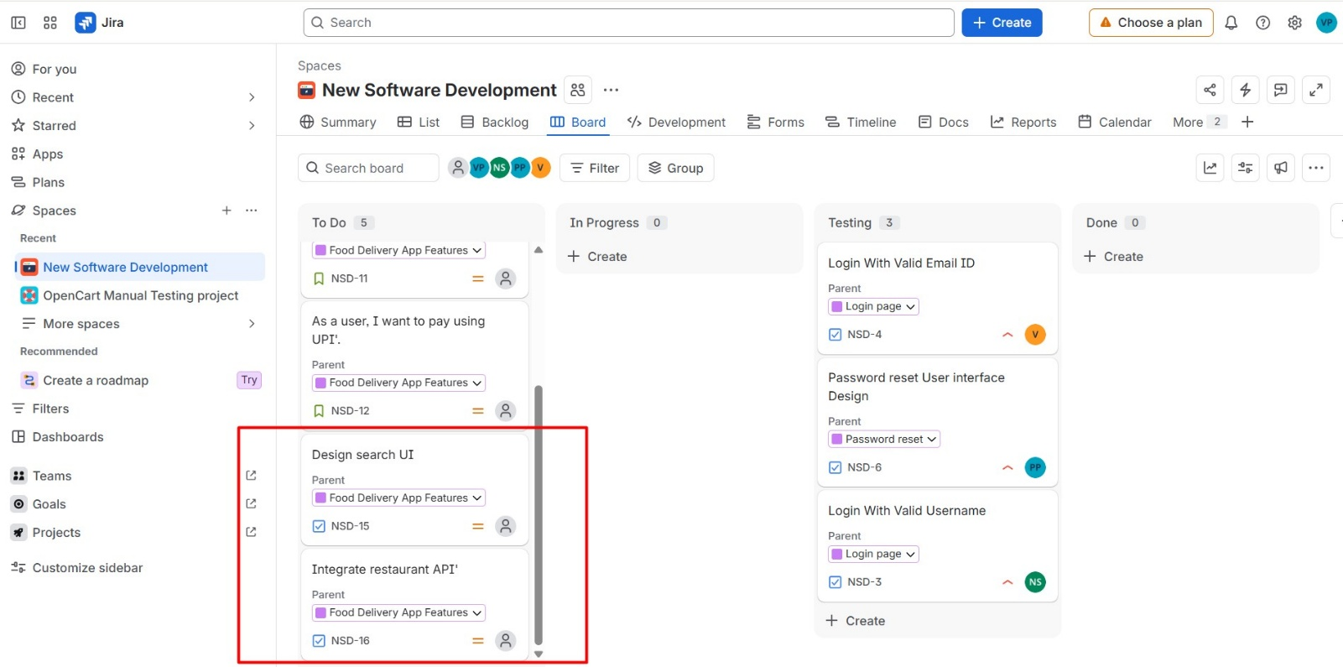
4. Change the status of one of your sub-tasks from 'To Do' to 'In Progress' and then to 'Done' using the Jira board workflow.<br><br><em><strong>Hint:</strong> Drag and drop the task across columns to update its status.</em>
Ans:
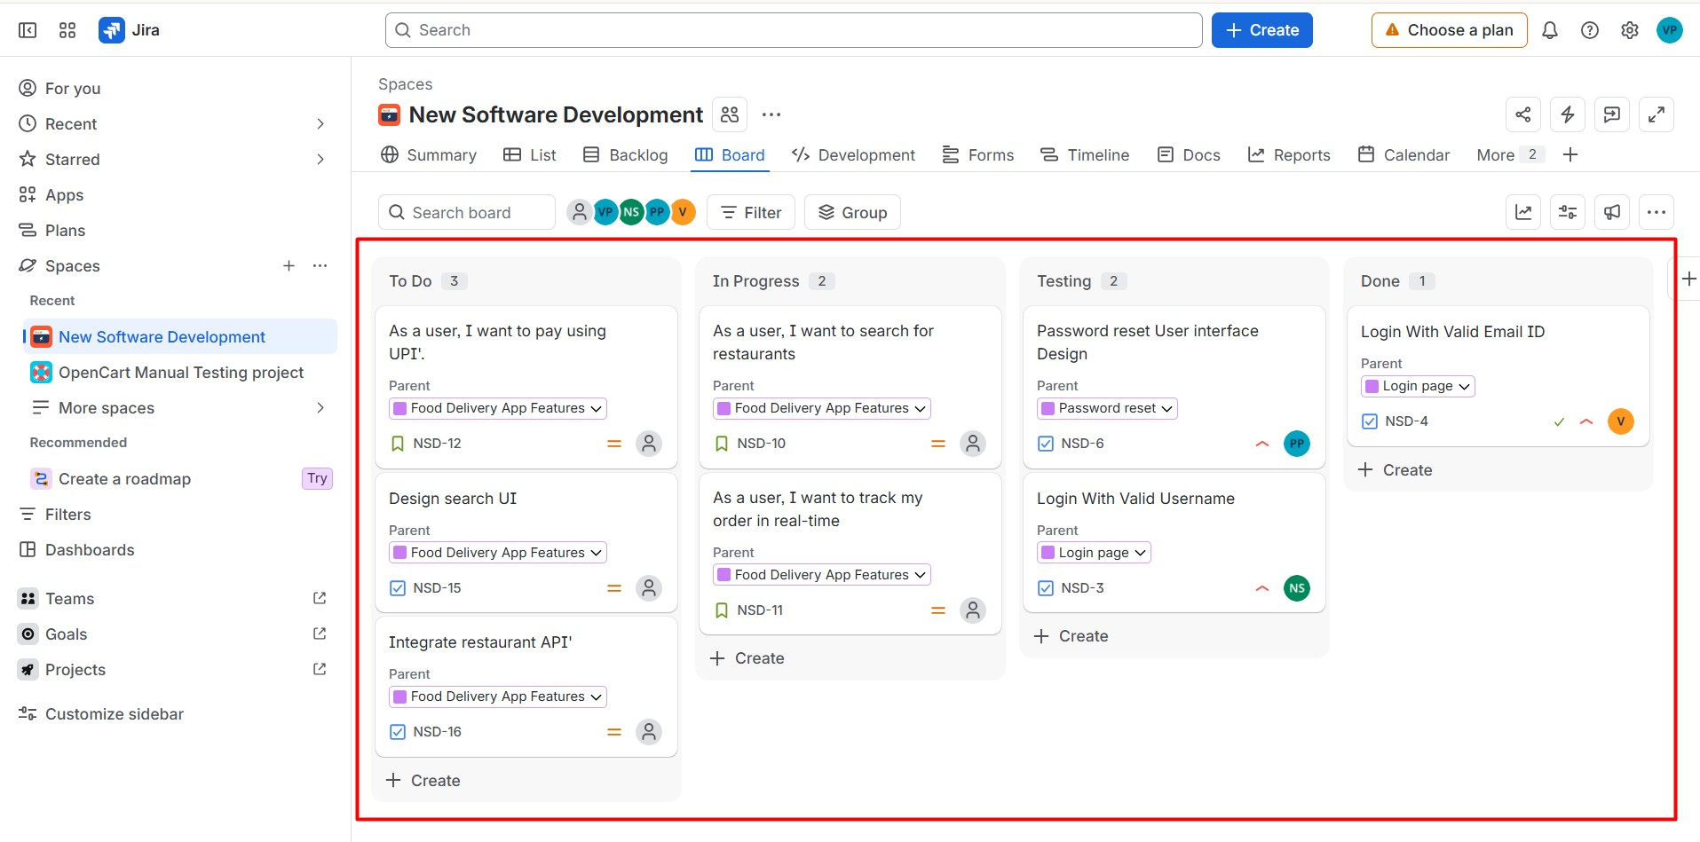

5. Explore the different issue types available in Jira (Epic, Story, Task, Bug). For each type, create a sample issue in your project and write one line explaining when you would use that issue type in a real Zomato or Swiggy-like app.
Ans:
